What does that button do?
(Main, Graph and Stat applications.)

Main application

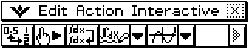

Converts between Fractional and decimal form at the cursor location (toggle).

Re−calulates the current line only.

Rewirtes an expression without simplification.

Denotes Mathematical symbolic mode.

Drop down for other applications. Here it shows the Graph application icon. Others are shown below.

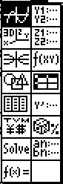
Graph application.
3D Graph application.
Conics application.
Geometry application.
Statistics application.
Financial application.
Solver application.
Verify application.
Graph editor window.
3D Graph editor window.
Conics editor window.
Spreadsheet application.
Diff eqn application.
Dice tossing application.
Sequence application.

Graph editor (y=) application

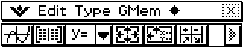

Click to graph ticked functions.

Table of values.

Type of function. (Other options include x =, r =, parametric, inequalities.)

Window settings.

Table settings (xstart, xend, xstep).

Sumary table showing key points (endpoints, max, min.)

Graph application



Edit function equations.

Table of values.

Window settings.

Table settings.

Zoom box.

Pan by dragging window.

Zoom to fill screen.

Graph toolbar continued:
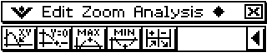

Trace.

Roots.

Maxima (use L/R arrow keys to find more).

Minima (use L/R arrow keys to find more).

Summary table.

Stat editor



Draw stats graph/s according to current graph settings.

Show Y= function editor.

Show Main application window.

Convert mathematical expression to a value.

Select graph types and which ones to plot.

Adjust window settings (may be overidden by “Stat window auto” under Set Graph menu).

Toggle bewteen various column layouts.

Stat editor toolbar continued.
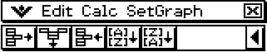

Edit → Delete cell.

Edit → Delete column.

Edit → Insert cell.

Sort in ascending order.

Sort in decending order.
Stat graph window



View lists of data.

View Y= menu.

Redraw graphs.

Window settings.

Trace.

Graph settings (type and which to plot).

Main application window.

Stat graph toolbar continued.


Zoom box.

Zoom in.

Zoom out.

Pan (by dragging).

Toggle “Stat graph window auto” on/off.

